Application for admission: Online application: https://tl1host.eu/SWHAL/#home
- Choose language
- Click on Application

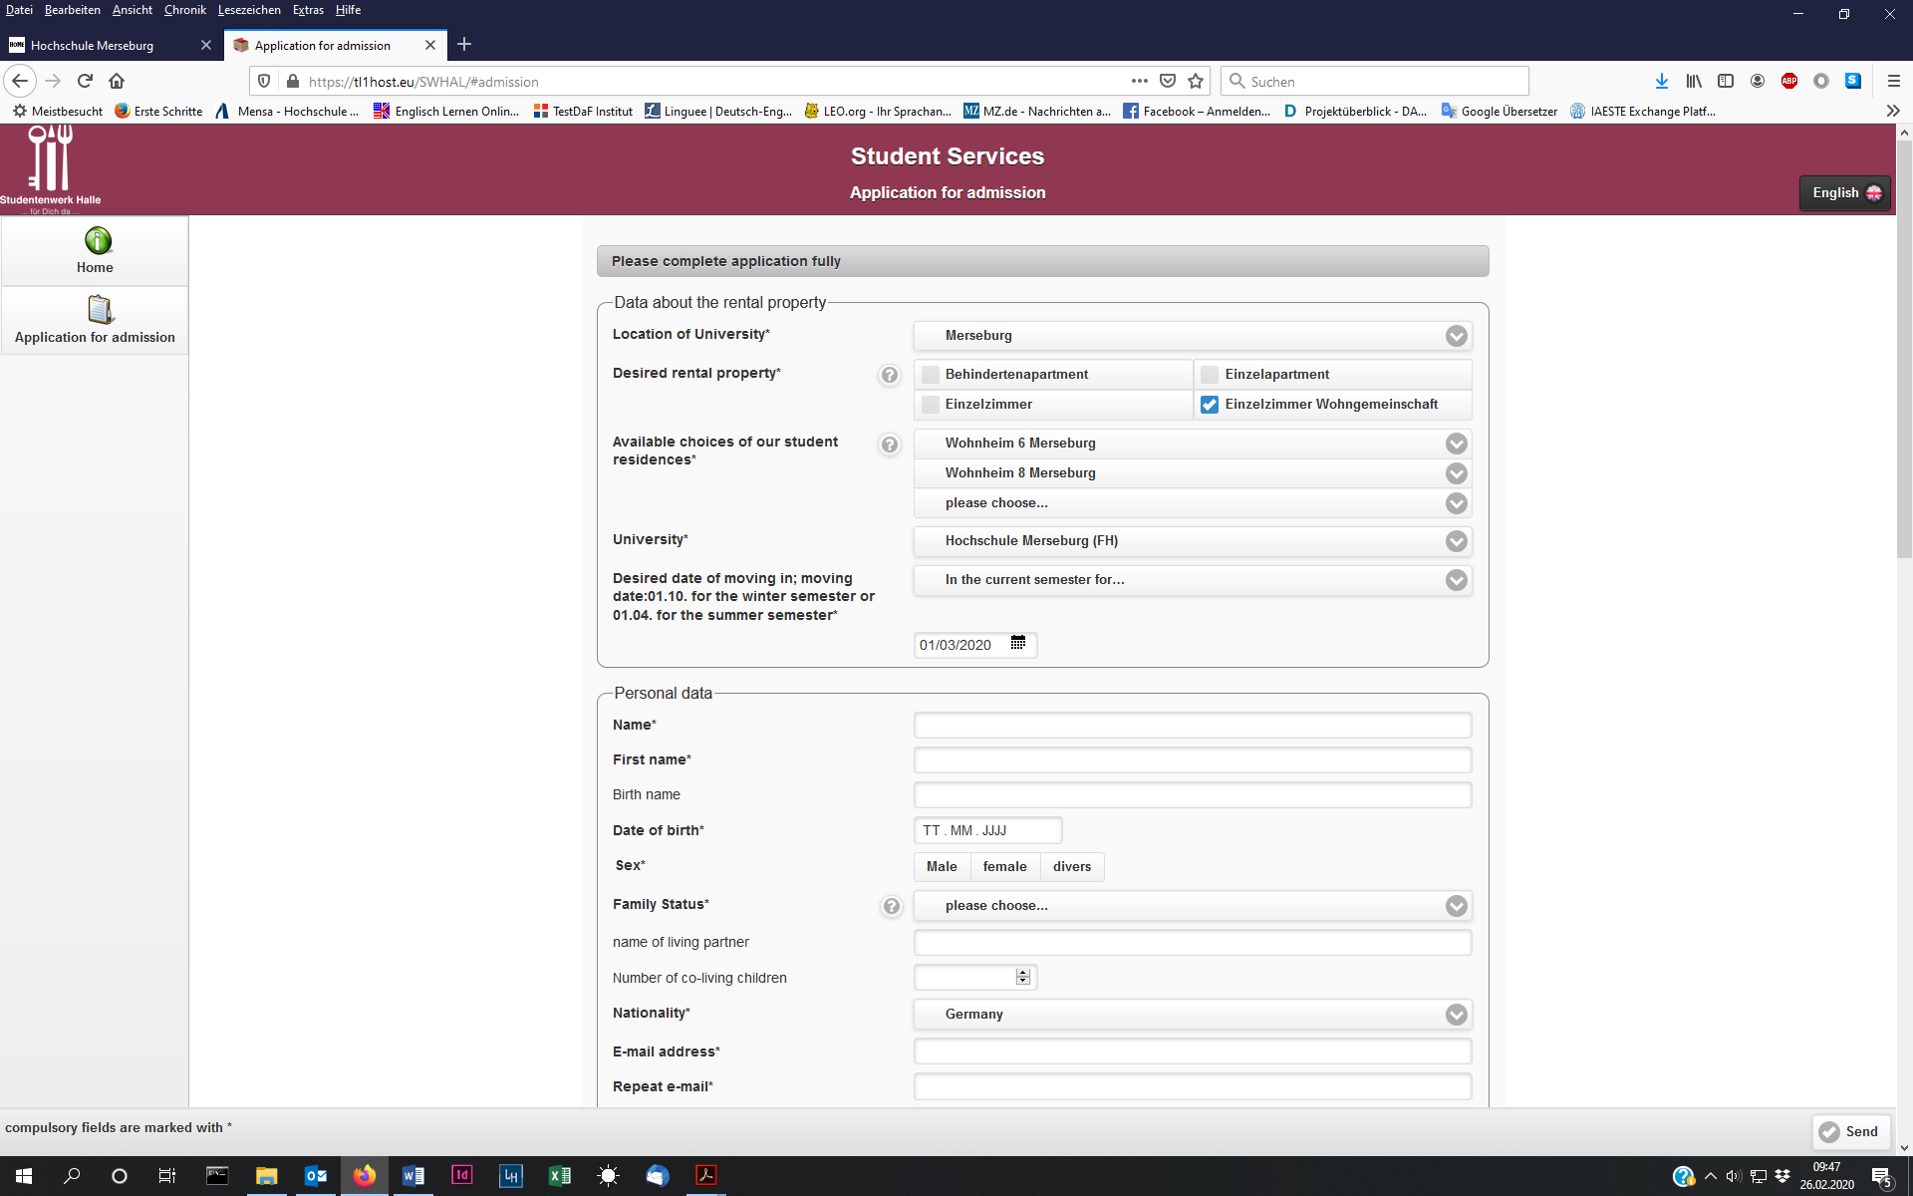

Complete the admission like this: (choose Wohnheim 6 and Wohnheim 8)

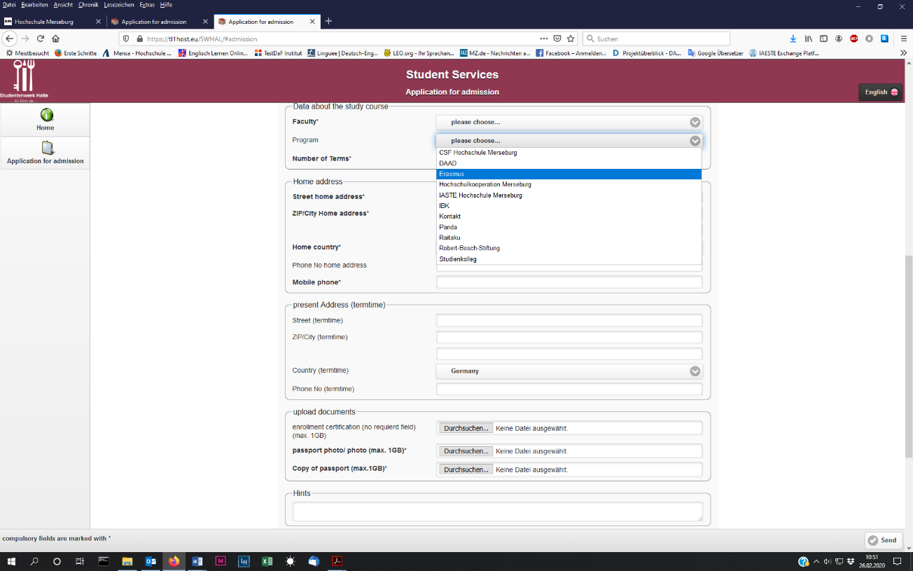

- Choose: IAESTE Hochschule Merseburg or Erasmus
- upload documents
- Hints: Enter the date of your stay

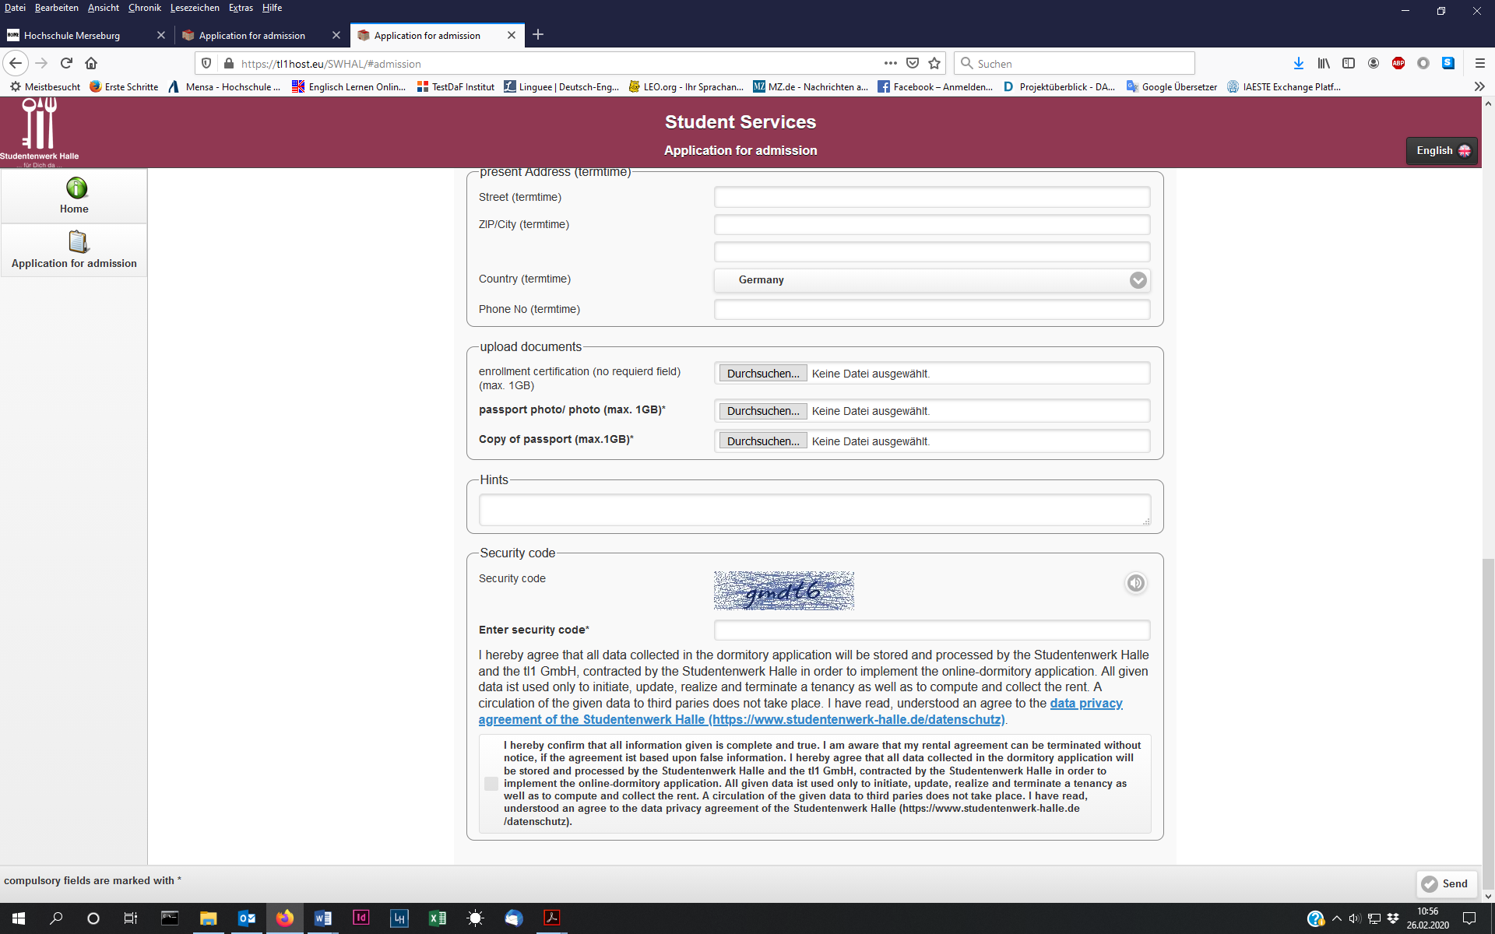

- Enter security code
- confirm
- send

